Part 1: Process Design (Figma / FigJam)
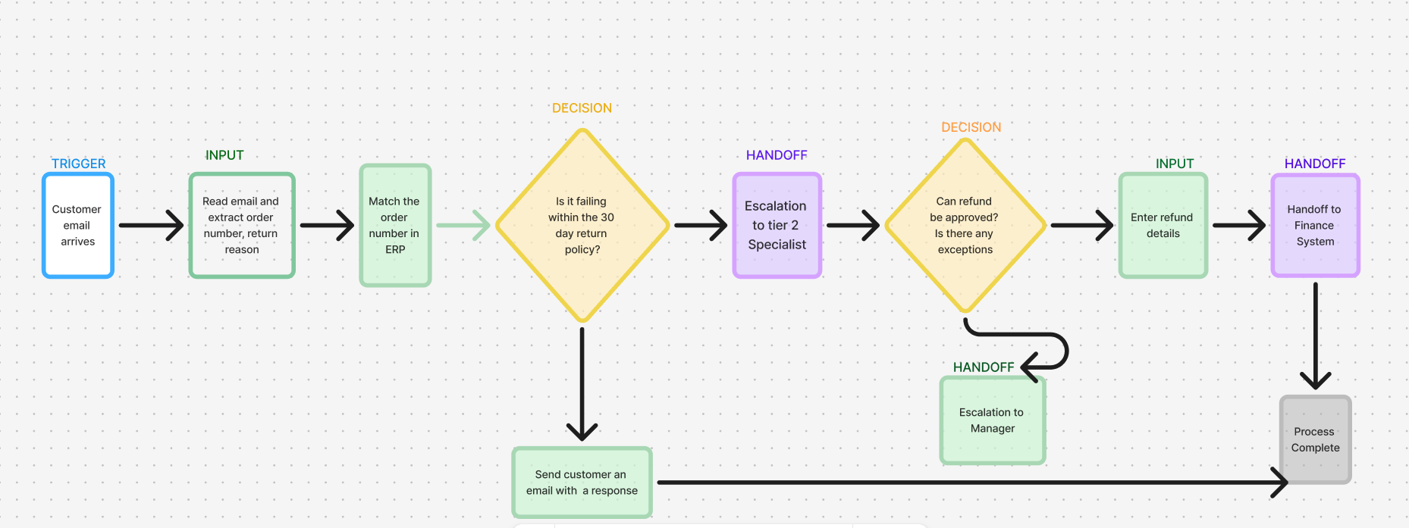
Future-state process map
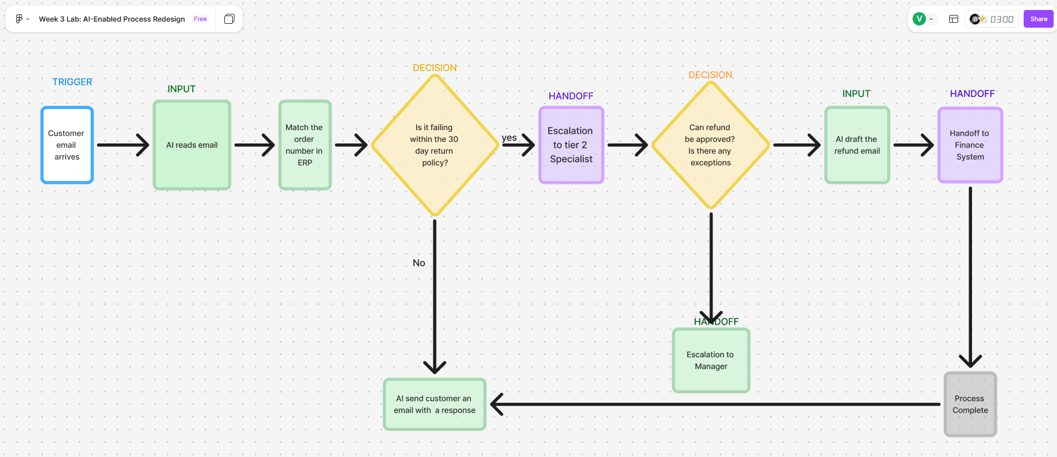

Part 2: Workflow Prototyping (n8n)
Screenshots of your n8n workflow canvas
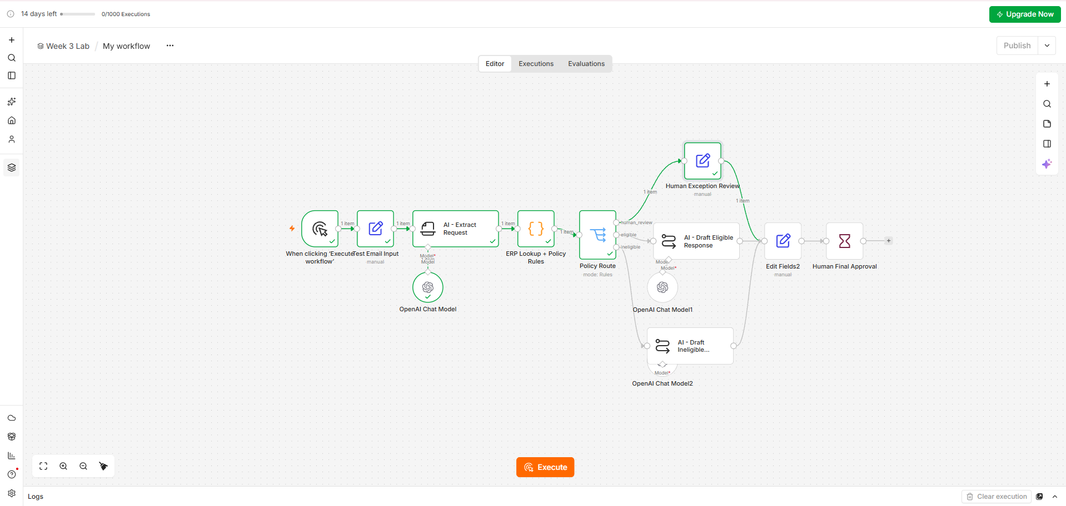

Test 1: The eligible return.

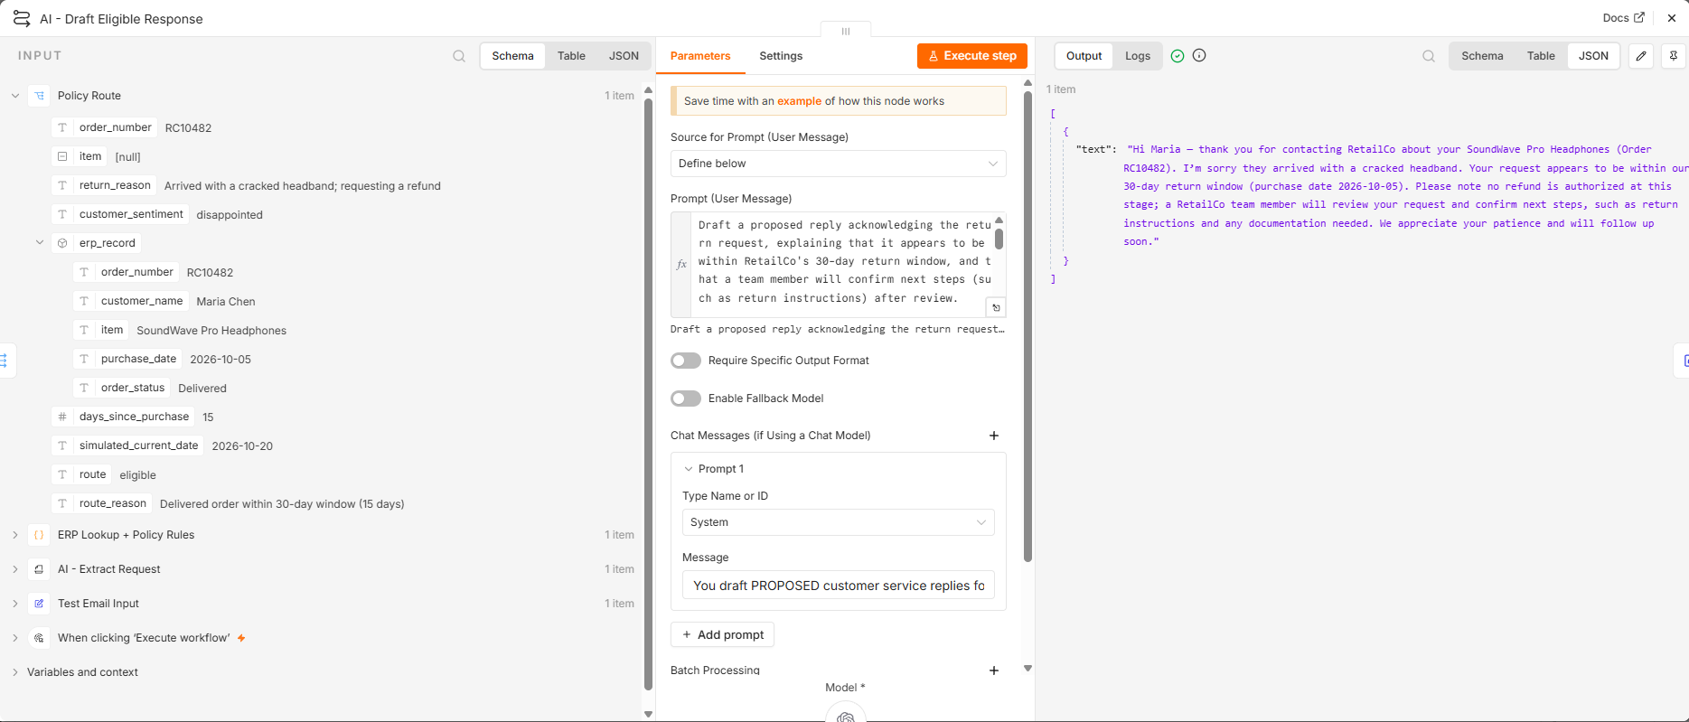

Test 2: The ineligible return (past 30 days).

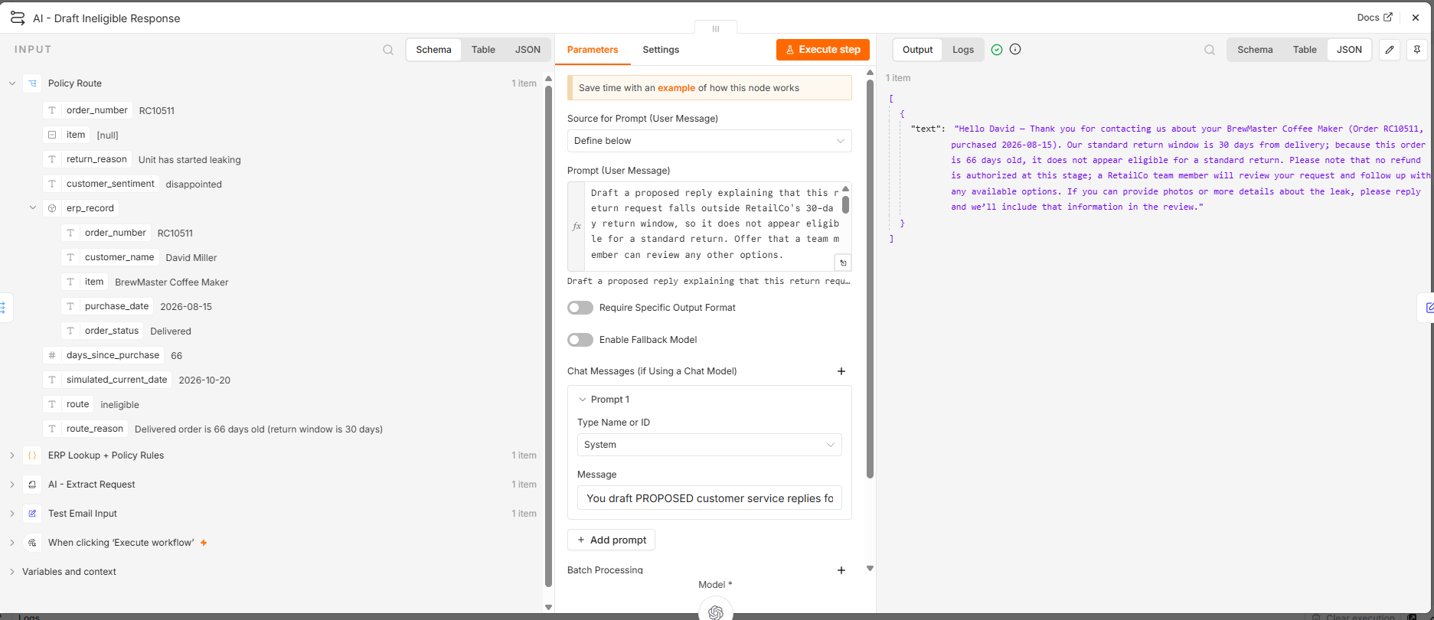

Test 3: The exception (missing order number).

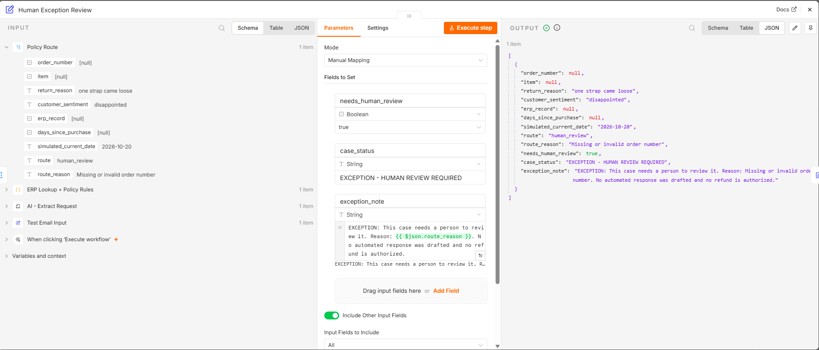

Test 4: The escalated/angry customer.

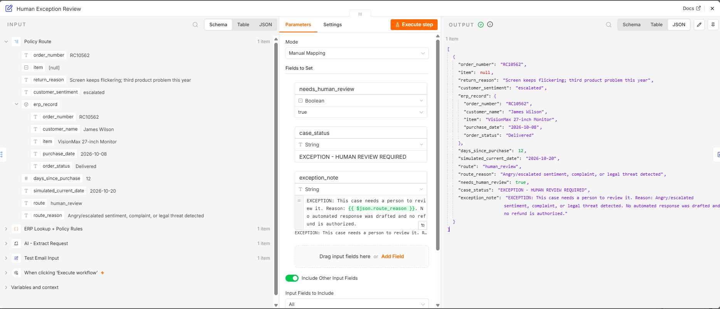
3.Managerial Analysis (2 paragraphs): Compare your n8n prototype with your Figma design. Did the prototype successfully enforce the deterministic ERP rule? Why was the human approval node necessary before the drafting step concluded?

The Figma presentation illustrates the customer refund process from when the company received the email to when we send the final decision. We have based how decision on the 30-day refund policy, escalation and approval request from human before sending the information to the finance department for the refund. We will be using AI to read the email and extract the order number and the reason for the return. After reading the email, we will still verify information with the company ERP system of record before human review.
The n8n prototype was build as recommended with first step the manual trigger, the input email process, in information extractor where we have the AI component, the component for the ERP system, the decision for human review if it is eligible or not eligible, the preparation of the statement after human review and the human final approval. This final approval allows a person to verify the decision and draft the communication before the process is finalized. When we compare the Figma workflow and the n8n process, they both required a clearer separation between AI interpretation, deterministic policy and human oversight.

